

***Miles Elementary School***

***Parent-Compact***

***For Achievement***

***2022-2023***

Ms. Thalise Perry, Principal Dr. Darnisha Johnson Assistant Principal

4215 Bakers Ferry Rd SW Atlanta, GA 30331

404-802-8900

<http://www.atlanta.k12.ga.u>[s/Domain/674](http://www.atlanta.k12.ga.us/Domain/674)

*Revised 10/2022*



***What is a***

***School-Parent Compact?***

*The families, students and staff of Miles Elementary developed this School-Family- Student Compact for Achievement.*

*Teachers suggested home learning strategies, families added ideas to make them more specific, and students told us what would help them learn. Meetings are held each year to review the Compact and make changes based on student needs.*

***Jointly Developed***

*The compact was jointly developed by the*

*school and parents.*

*It shall be distributed and returned by all parents of the school, signed and dated.*

*Made available on the school website, Main Office, Parent Center as well as sent home to all parents/guardians.*

*Describe opportunities for parents to volunteer and be engaged at school and home.*

*Parents are welcome to contribute comments at any time.*

*Used as a strategy to address/share student progress during parent- teacher conferences*

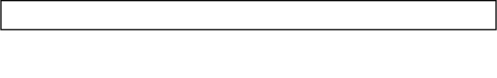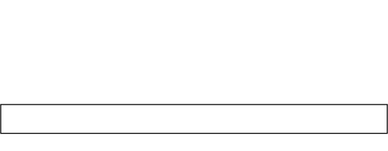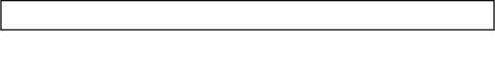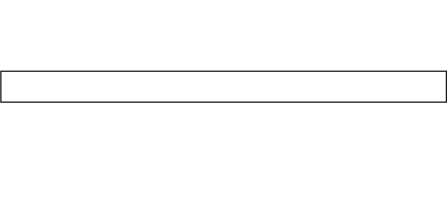

***Activities to Build Partnerships***

**COMMUNICATING**

School Newsletter Social Media Flyers

Email

Phone Contacts and Robo Calls

**VOLUNTEERING**

Our School Volunteer Hours:

8am-10 or 11am-1pm Front Office

**LEARNING AT HOME**

Georgia Standards of Excellence & Standardized Testing Resources

Catalog of materials available in the Parent

Center is available upon request

**DECISION MAKING**

**Title I Annual Meeting October, December, & April**

GoTeam & Parent Advisory Committee

***Digital Parent Resource Center currently under construction***

***Teachers, Parents, and Students—Together for Success***

# Teacher/School Responsibilities

* *Provide academic critical writing and thinking skills and activities in ELA by implementing guided reading groups, phonics skills, and Lucy Calkins writing curriculum during the reading instructional block.*
* *Provide Parent Conferences, Parent Universities, Principal Chat and Chews, and APTT meetings for teaching and supporting parents to help improve their child with reading abilities at home.*
* *Provide families with opportunities to review students reading data.*

# Family Responsibilities

* *Parents will attend Parent Education Workshops, Interactive Events, and Information Sessions to learn additional ways to build literacy, problem solving, and critical thinking skills at home in order to meet school expectations.*
* *Parents will use reading strategies and educational concepts to support the learning at school.*
* *Parents will utilize the suggested resources to build reading comprehension in all content areas and increase academic achievement and ensure students read 30 minutes each night.*



***Our Goals for Student Achievement District Goal***

*Develop an academic program that our students will be well-rounded individuals who possess the necessary academic skills and knowledge and are excited about learning*

***School Goals***

*This compact pledges our school family to increase student academic achievement performance in the areas of Literacy and Math in order to show an increase in our school MAP Data.*

*Miles’ goals from the Continuous Improvement Plan are as follows:*

* *By Spring 2023, Miles ES will show 5-10% growth in ELA as measured by the MAP assessment.*
* *By Spring 2023, Miles ES will show 5-10% growth in Math as measured by the MAP assessment.*
* *Decrease the number of students scoring “high risk” on the BASC screener by 5-10% Spring 2023.*

# Student Responsibilities

* + ***Will participate in remediation that will assist in increasing their ability to read for fluency and comprehension.***
  + ***Students will utilize Accelerated Readers and Intervention Technology Platforms to improve reading fluency and comprehension.***
  + ***Students will review reading classwork and complete homework nightly.***